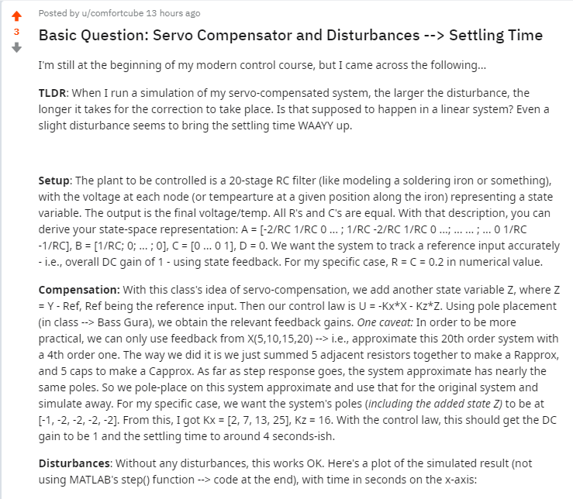

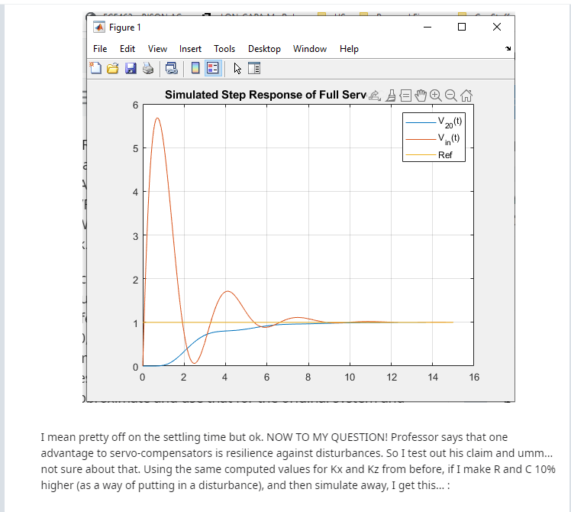

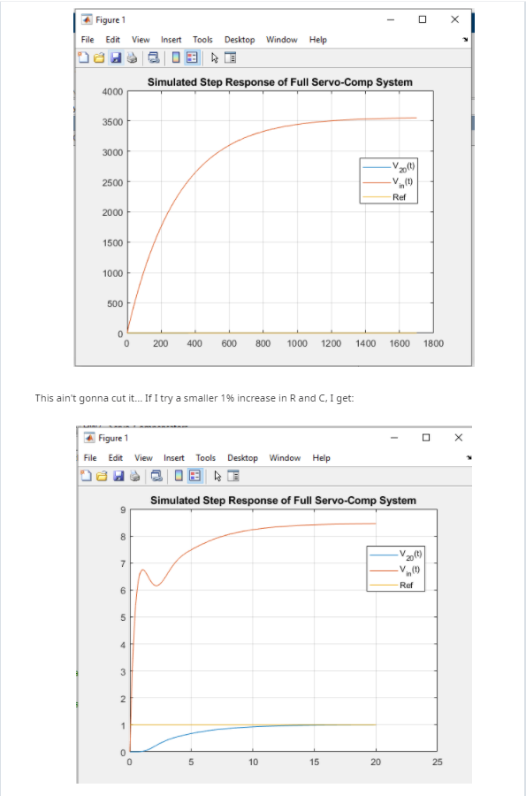

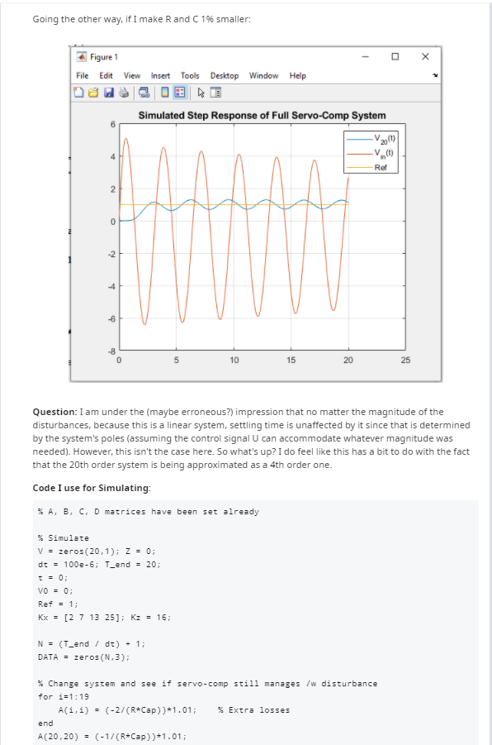

**% System description**

**R = 0.2; Cap = 0.2;**

**A = zeros(20,20);**

**for i=1:19**

**A(i,i) = -2/(R*Cap);**

**A(i,i+1) = 1/(R*Cap);**

**A(i+1,i) = 1/(R*Cap);**

**end**

**A(20,20) = -1/(R*Cap);**

**B = zeros(20,1);**

**B(1) = 1/(R*Cap);**

**C = zeros(1,20);**

**C(20) = 1;**

**D = 0;**

**% Simulate**

**V = zeros(20,1); Z = 0;**

**dt = 100e-6; T_end = 20;**

**t = 0;**

**V0 = 0;**

**Ref = 1;**

**Kx = [2 7 13 25]; Kz = 16;**

**N = (T_end / dt) + 1;**

**DATA = zeros(N,3);**

**% % Change system and see if servo-comp still manages /w disturbance**

**% for i=1:19**

**% A(i,i) = (-2/(R*Cap))*0.99; % Extra losses**

**% end**

**% A(20,20) = (-1/(R*Cap))*0.99;**

**i=1;**

**tic**

**while(t < T_end)**

**% while(abs(V(20) - Ref) > 0.005*Ref)**

**V0 = -Kz*Z - Kx*V([5,10,15,20]) - 10;**

**dV = A*V + B*V0;**

**dZ = V(20) - Ref;**

**V = V + dV * dt;**

**Z = Z + dZ * dt;**

**t = t + dt;**

**DATA(i,:) = [V(20), V0, Ref];**

**i = i+1;**

**end**

**toc**

**t = [1:length(DATA)]' * dt;**

**DATAds = downsample(DATA,100);**

**tds = downsample(t,100);**

**plot(t,DATA);**

**grid on;**

**legend('V_{20}(t)','V_{in}(t)','Ref');**

**title('Simulated Step Response of Full Servo-Comp System');**

